Postal Life Insurance

Department of Post

Software Requirements Specification (SRS)/ Functional Requirements Specification (FRS)
  - BBPS Integration

INTERNAL APPROVAL FORM

Project Name: BBPS Integration
Version: 1.0
Submitted on:
 | Name | Date
Approved By:
Reviewed By:
Prepared By:

VERSION CONTROL LOG
Version | Date | Prepared By | Remarks
1

Table of Contents

1. Executive Summary 4
2. Project Scope 4
3. Business Requirements 4
4. Functional Requirements Specification 5
4.1 Policy Validation API 6
4.2 Payment Initiation API 6
4.3 Payment Status API 7
4.4 Refund/Reconciliation API 7
4.5 Error Codes 8
5. Attachments 8

1. Executive Summary
This document outlines the requirements for integrating the Insurance Management System (IMS) of India Post PLI with the Bharat Bill Payment System (BBPS) via Bharat e-Connect. The integration will enable policyholders to pay premiums using UPI apps and other digital payment modes.

2. Project Scope
This Module will:
- Allow policyholders to pay premiums (due or advance) via BBPS.
- Enable real-time validation of policy details.
- Generate receipts instantly.
- Ensure secure and transparent transaction flow.
- Automate reconciliation through the Nodal Office.

3. Business Requirements

ID | Functionality | Requirements
FS_BBPS_001 | BBPS Integration | IMS must integrate with NPCI BBPS via Bharat e-Connect for premium payments.
FS_BBPS_002 | Policy Validation | Customer should enter Policy Number and DOB; IMS validates details in real-time.
FS_BBPS_003 | Premium Fetch | IMS should fetch due premium or allow advance payment (up to 12 months).
FS_BBPS_004 | Payment Options | Customer should be able to pay via UPI, Cards, Net Banking, e-Wallets.
FS_BBPS_005 | Banking Partner | SBI will act as the BBPS banking partner for transaction processing.
FS_BBPS_006 | Receipt Generation | IMS must generate and share digital receipts post successful payment.
FS_BBPS_007 | Error Handling | Display clear error messages for invalid policy or failed transactions.
FS_BBPS_008 | Refund & Reconciliation | Nodal Office should handle refunds and reconciliation for failed payments.
FS_BBPS_009 | Security | All data exchanges must be encrypted and comply with RBI/NPCI norms.
FS_BBPS_010 | Compliance | Integration must adhere to BBPS and RBI guidelines for digital payments.

4. Functional Requirements Specification
Visual Flow Diagram for BBPS Integration: 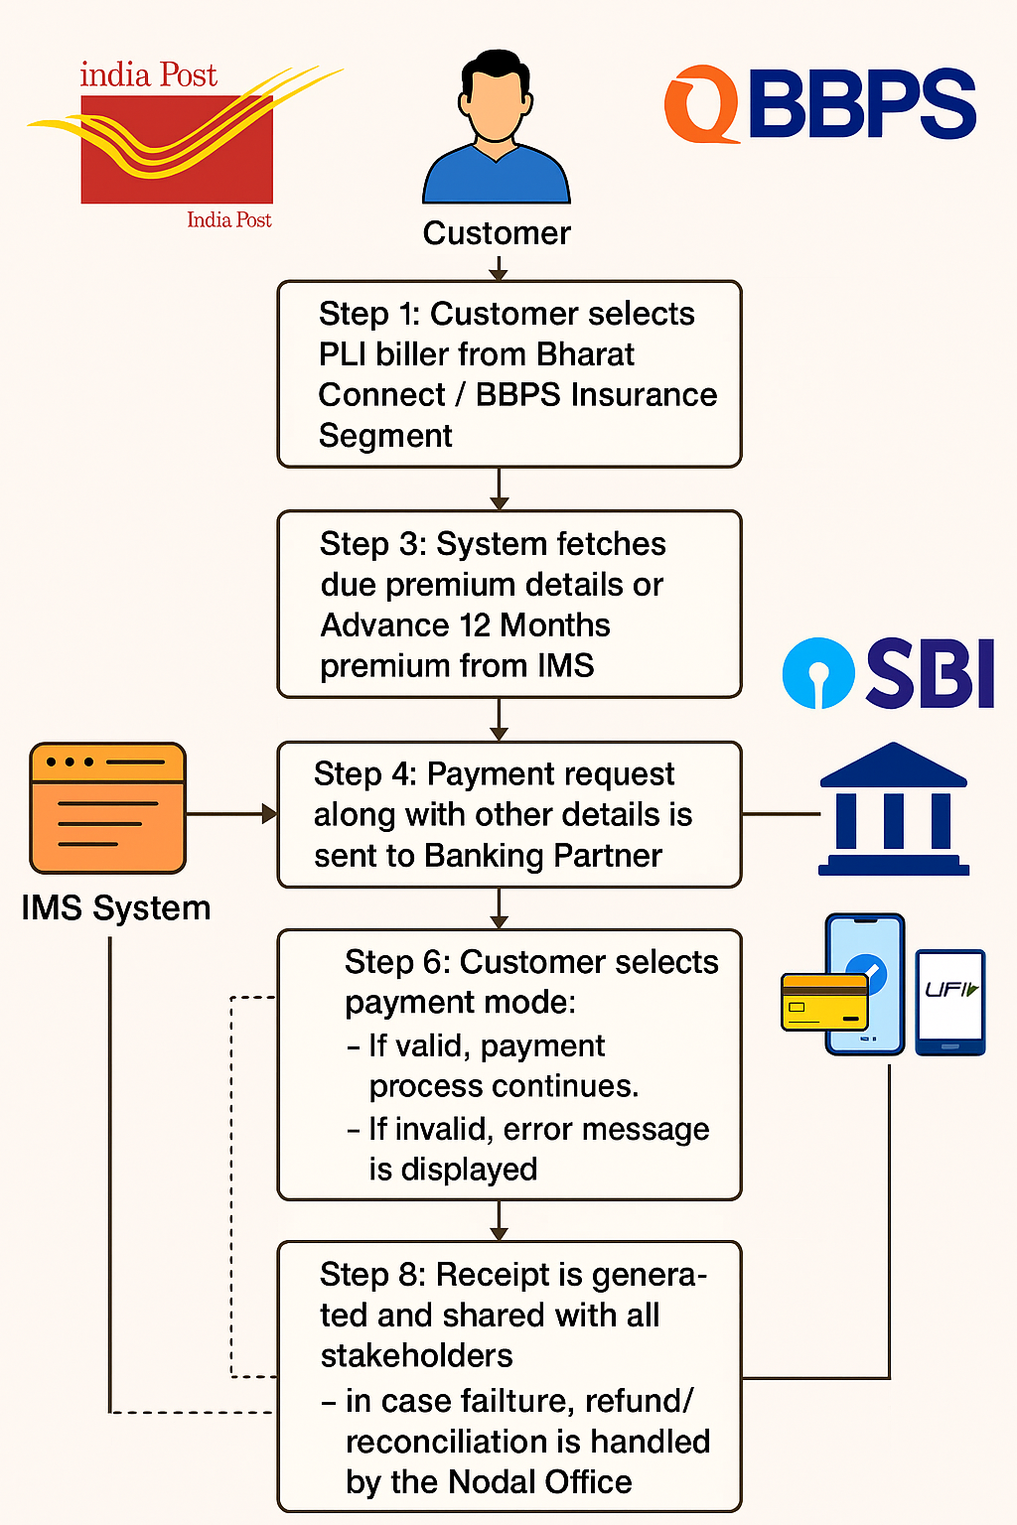

4.1 Policy Validation API
- Purpose: To validate the customer’s policy details and fetch premium information before initiating payment.

4.1.1 Request Structure (IMS → BBPS API: Policy Validation API)

Field Name | Type | Description
policyNumber | String | Unique policy number of the customer
dateOfBirth | Date | Customer’s date of birth in YYYY-MM-DD format
txn | String | Unique transaction ID (UUID)
ts | DateTime | Timestamp in ISO format
channel | String | Payment channel (BBPS)
consent | Boolean | Customer consent flag

4.1.2 Response Structure (BBPS → IMS: Policy Validation)

Field Name | Type | Description
txn | String | Same transaction ID for mapping
status | String | Validation result (SUCCESS / ERROR)
premiumDue | Decimal | Premium amount due
advanceAllowedMonths | Integer | Maximum months allowed for advance payment
message | String | Status message
ts | DateTime | Response timestamp

4.2 Payment Initiation API
- Purpose: To initiate the payment process by sending payment details to BBPS and receiving a payment link or status.

4.2.1 Request Structure (IMS → BBPS API: Payment Initiation API)

Field Name | Type | Description
policyNumber | String | Customer’s policy number
amount | Decimal | Payment amount
paymentType | String | FULL / ADVANCE
txn | String | Unique transaction ID
ts | DateTime | Timestamp in ISO format
bankPartner | String | Banking partner (SBI)
consent | Boolean | Customer consent flag

4.2.2 Response Structure (BBPS → IMS: Payment Initiation API)

Field Name | Type | Description
txn | String | Same transaction ID
status | String | Payment status (PENDING / SUCCESS / FAILED)
paymentUrl | String | URL for payment completion
message | String | Status message
ts | DateTime | Response timestamp

4.3 Payment Status API
- Purpose: To check the current status of a payment transaction.

4.3.1 Request Structure (IMS → BBPS API: Payment Status API)

Field Name | Type | Description
transactionId | String | Unique transaction ID
ts | DateTime | Timestamp in ISO format

4.3.2 Response Structure (BBPS → IMS: Payment Status API)

Field Name | Type | Description
txn | String | Same transaction ID
status | String | Payment status (SUCCESS / FAILED)
receiptUrl | String | URL for digital receipt
message | String | Status message
ts | DateTime | Response timestamp

4.4 Refund/Reconciliation API
- Purpose: To initiate refund or reconciliation for failed or disputed transactions.

4.4.1 Request Structure (IMS → BBPS API: Refund/Reconciliation API)

Field Name | Type | Description
transactionId | String | Unique transaction ID
reason | String | Reason for refund
ts | DateTime | Timestamp in ISO format

4.4.2 Response Structure (BBPS → IMS: Refund/Reconciliation API)

Field Name | Type | Description
refundId | String | Unique refund ID
status | String | Refund status (INITIATED / COMPLETED)
expectedCompletion | DateTime | Expected completion date
message | String | Status message

4.5 Error Codes

Error Code | Description
100 | Success – Transaction successful
200 | Invalid Policy Number
210 | Policy details mismatch
300 | Invalid Amount
310 | Amount exceeds allowed limit
400 | Payment declined by bank
410 | Payment timeout
500 | Technical error at BBPS
510 | Service unavailable
999 | Unknown error

5. Attachments
The following documents can be referred.

